

Starts

**Our New Attendance Incentive**

Monday 19th April

For 4 weeks

[](https://www.google.co.uk/url?sa=i&url=https%3A%2F%2Fthedecoratedcookie.com%2Fsimple-sprinkley-birthday-cookies%2F&psig=AOvVaw3cbtcTPMypobRKd0-ojy2U&ust=1618400366359000&source=images&cd=vfe&ved=0CAIQjRxqFwoTCOjF8b-T--8CFQAAAAAdAAAAABAS)Top Prize: Raffle draw for £20 Tesco Voucher

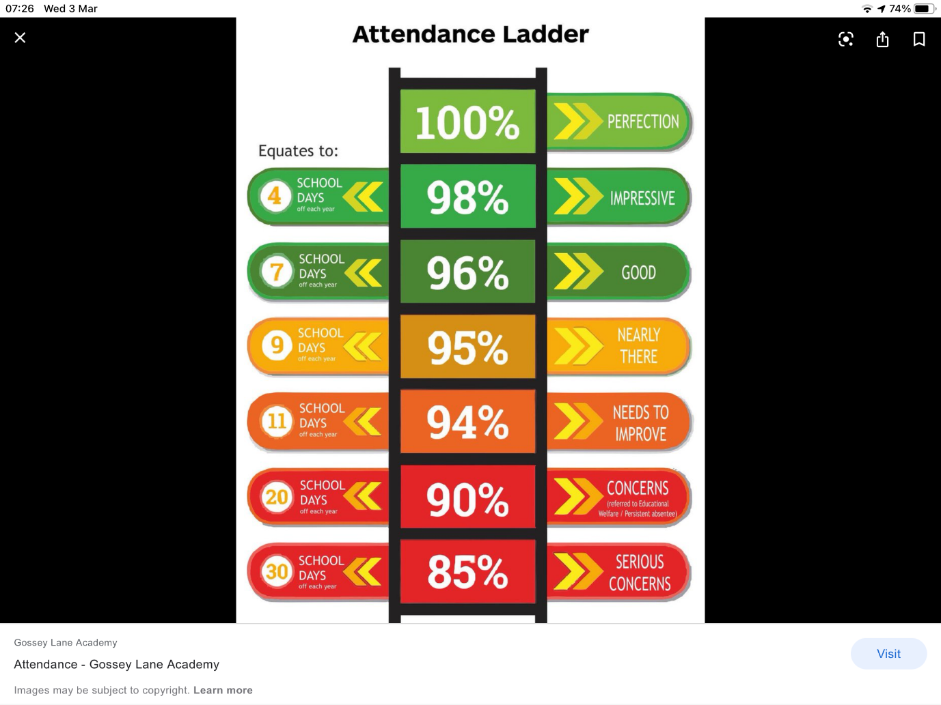Cookie Decorating for all who achieve 100%

**We don’t want to be here!**

**Let’s strive for Perfection!**

**Keep trying!**

**This would be impressive!**